Develop Coding: Assignment



Student Name: Daniel Monaghan

1. IT, in this project, played an important role in planning that kept the project on track. Using Trello I planned the individual pieces of the project and using visual studio code I used Emmet Snippets to speed up my work on the project and saving time across these past few days. Using KABAN has kept my project on-track by reminding me of the next task every time I would move another completed item to the “complete” list. This simple to-do functionality stopped me from getting too distracted with smaller details as I had an overview of the project at all steps. The target audience for this site is for fans of the Zelda franchise.
2. Whilst working on the Legend of Zelda website I had encountered challenges that, although I was familiar with, gave me some stumbling blocks and hurdles along the way. Flexbox is new feature of CSS that I am less familiar with and I found this difficult to work with but a pleasure after an adjustment period.   
   Whilst working on the Legend of Zelda website I had encountered challenges that, although I was familiar with, gave me some stumbling blocks and hurdles along the way. Flexbox is a new feature of CSS that I am less familiar with and I found this difficult to work with but a pleasure after an adjustment period.

I chose a colour scheme using an online tool to colour match a picture of the protagonist of the game, Link, this choice was a huge benefit to the project as the whole site looks “on-brand”. Using CSS variables in the project helped keep my colour work consistent.

1. As part of the styling for the content of the website, I hunted down the fonts for the game from resources like https://zeldauniverse.net/media/fonts/ and adobe fonts. These fonts are used in an educational setting for non-commercial purposes. GDPR and Copyright affect the development process of web design due to the public nature of the web, Copyright holders have the right to withhold access to their intellectual property to protect that IP from misuse and GDPR protects people’s data from falling in the wrong hands and making sure that all parties involved (dev-user, user-server provider, dev-server provider) are aware of how data should be correctly handled. If a GDPR breach is in play then the data controller of the legal entity that stores the data has an obligation to inform users of the breach and notify them of which data has been breached, this is protection for the users and there are other GDPR regulations that control portability of data and you must also provide your users with a means to be “forgotten”.
2. I have been very happy with using Trello to plan my projects and make myself a roadmap as I go to stay on topic, as with all tools there are drawbacks and benefits to each one, one thing that I have found a constant bother throughout this project is Visual Studio Code’s autocomplete feature that would add the end tag to an element I had added without prompt to do so, this feature was useful in some cases but a nuisance in others when I didn’t need it.
3. To make sure my site looked correct I checked to see if the design would work on mobile, it does not. Although on a desktop this site looks perfect albeit a little rough around the edges in places. For my transparent images, I have used PNG as they preserve transparency, my icons use a mix of TTF and OTF fonts hosted with the project and imported with the CSS @font-face selector and for non-transparent images, I have used JPG files as the file size is smaller when dealing with graphical images like photos. My site is not mobile-friendly, given more time to work on the site and more features, namely media queries, I would be able to make this site more accessible. Currently, the site is visible by screen readers and is also written in a way that allows for a “simplified view” on mobile making it easier to read.
4. During the majority of this project I have used Emmet snippets in Visual Studio Code, not only to speed up typing but also as a safeguard from typos as the end tags for HTML and autocomplete for CSS would sometimes break existing code, Emmet snippets saved me a google search in most cases as a trial and error approach works well with CSS.
5. My website is a pseudo fansite for demonstration purposes on the topic of Legend of Zelda - Breath of the Wild and is in no way a complete product. The theme and colours are based on the game’s colour scheme, a clean Blue (Hero’s blue), the colour of the hair of link for the gold colour (‘Triforce Gold’) and the colour of the game over screen text for the red, this in combination with a brown that I colour matched from his boots using Coloors’ colour picker, the result of my colour scheme is seen in fig 3. My first page contains a brief summary of the Legend of Zelda game franchise taken from either the Nintendo website, the text is centred and the font is a close match to the in-game dialogue font, a typical dialogue trick that the Zelda games use to emphasise text (usually when some sort of deity or god is talking) is that it will have a gold glow to show that it is “holy”. In the previous game, Twilight Princess, this was used as the default dialogue style. At the top of each page, there is a Title of the site and an interactive navigation bar that shows the current page with a highlight, this was achieved by giving the .active class to the active a tag which adds a filter of 125% brightness to the element it is on. the gallery and store pages use the :active pseudo-class to provide a different style on the elements that are clicked and held on, on the release of the mouse click the state of the element changes back from :active to normal, I used this trick on the img tags for Gallery and on the div’s on the store. Using the :hover pseudo class to manipulate the size of the element that was being hovered over, these two techniques resulted in a card style horizontal scrollbox on the gallery page (similar to Facebook’s suggested friends sections) and a grid layout on the store page. Given more time I would make these more functional as a good exercise to help me understand absolute positioning in greater detail.
6. Please find below a screenshot of my website in 2 browsers (Google Chrome and Microsoft Edge)

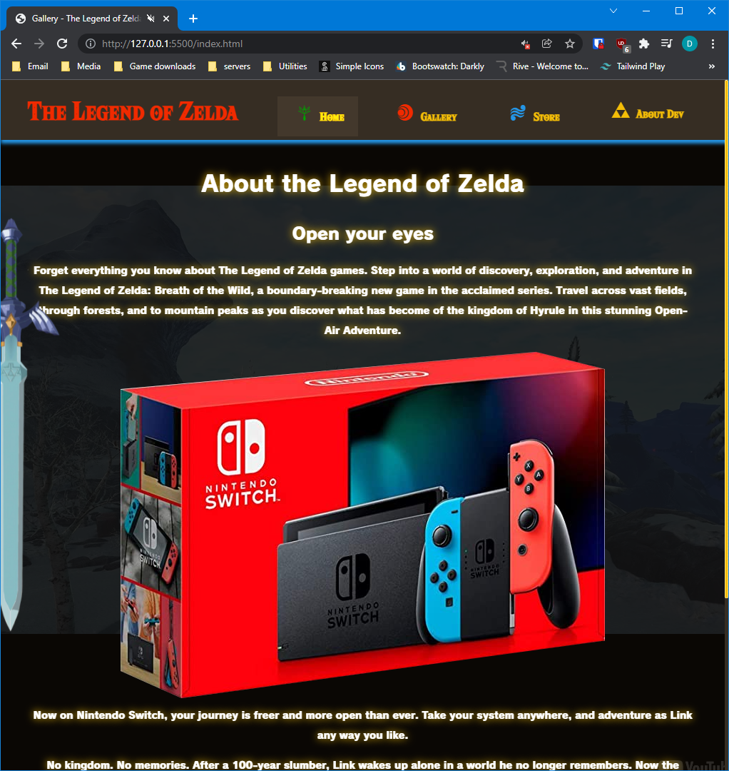

Figure 1 - Chrome Browser

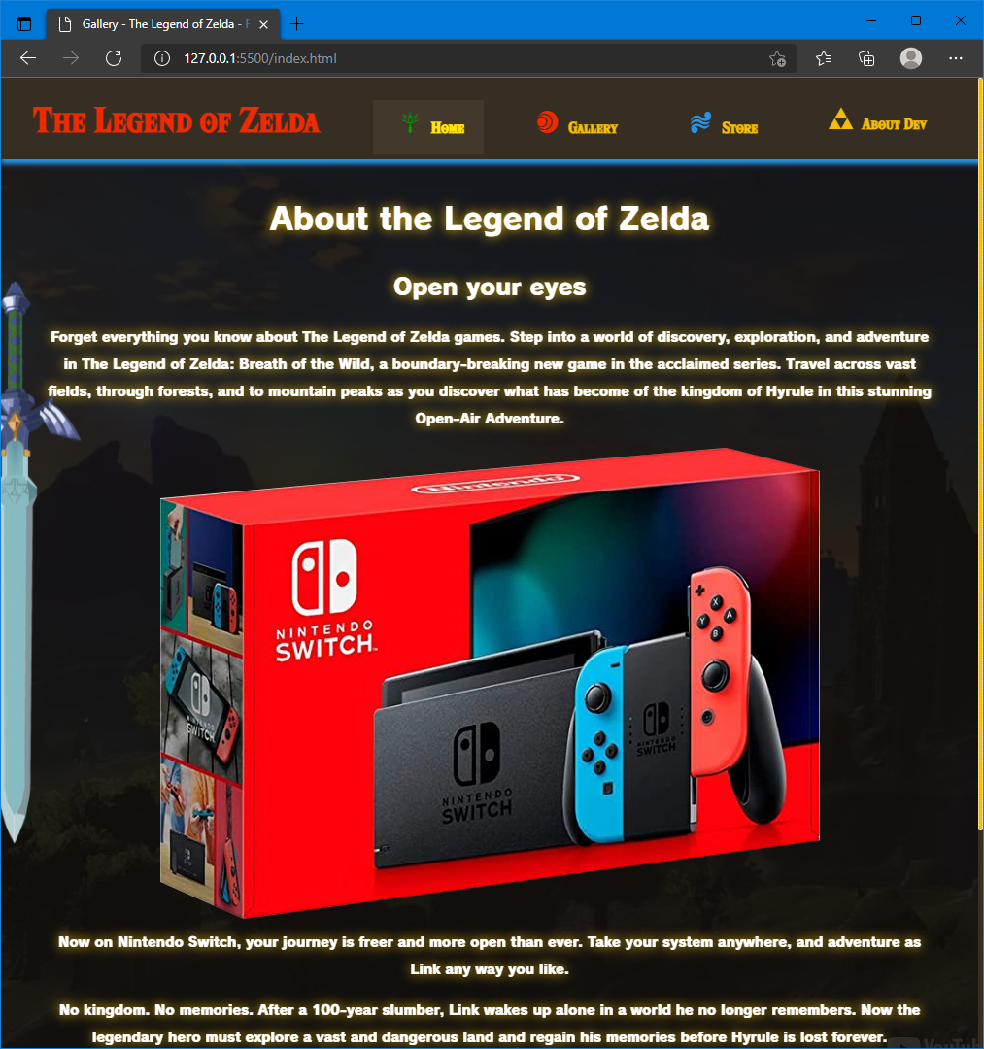

Figure 2 - MS Edge Browser

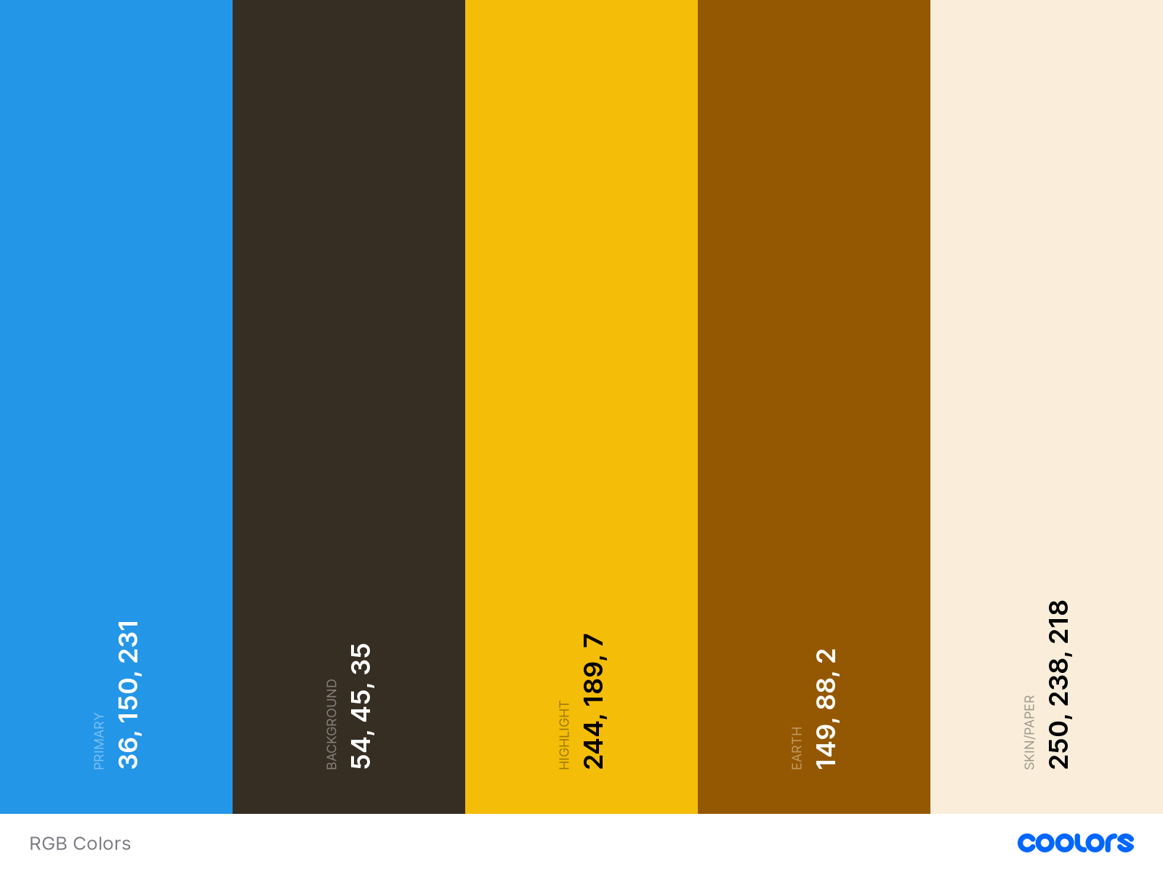

Figure 3 - Colours